- EXERCISE

- The Elusive Summer of ’68 is a lyrical story about a Serbian simple-minded young man Petar, who lives in an idyllic and patriarchal Serbian province that is echoed by turbulent world events. His clumsy courtship and summer maturation are connected through episodes from the life of the province, which is still affected by images of student riots in front of the Paris Sorbonne, burning napalm bombs in Vietnam, mass youth protests stopped in front of the New Belgrade overpass to wait for Marshal Tito's address ...

- The Elusive Summer of ’68 is a sentimental author's testimony about the behavior of small people in one important historical year.

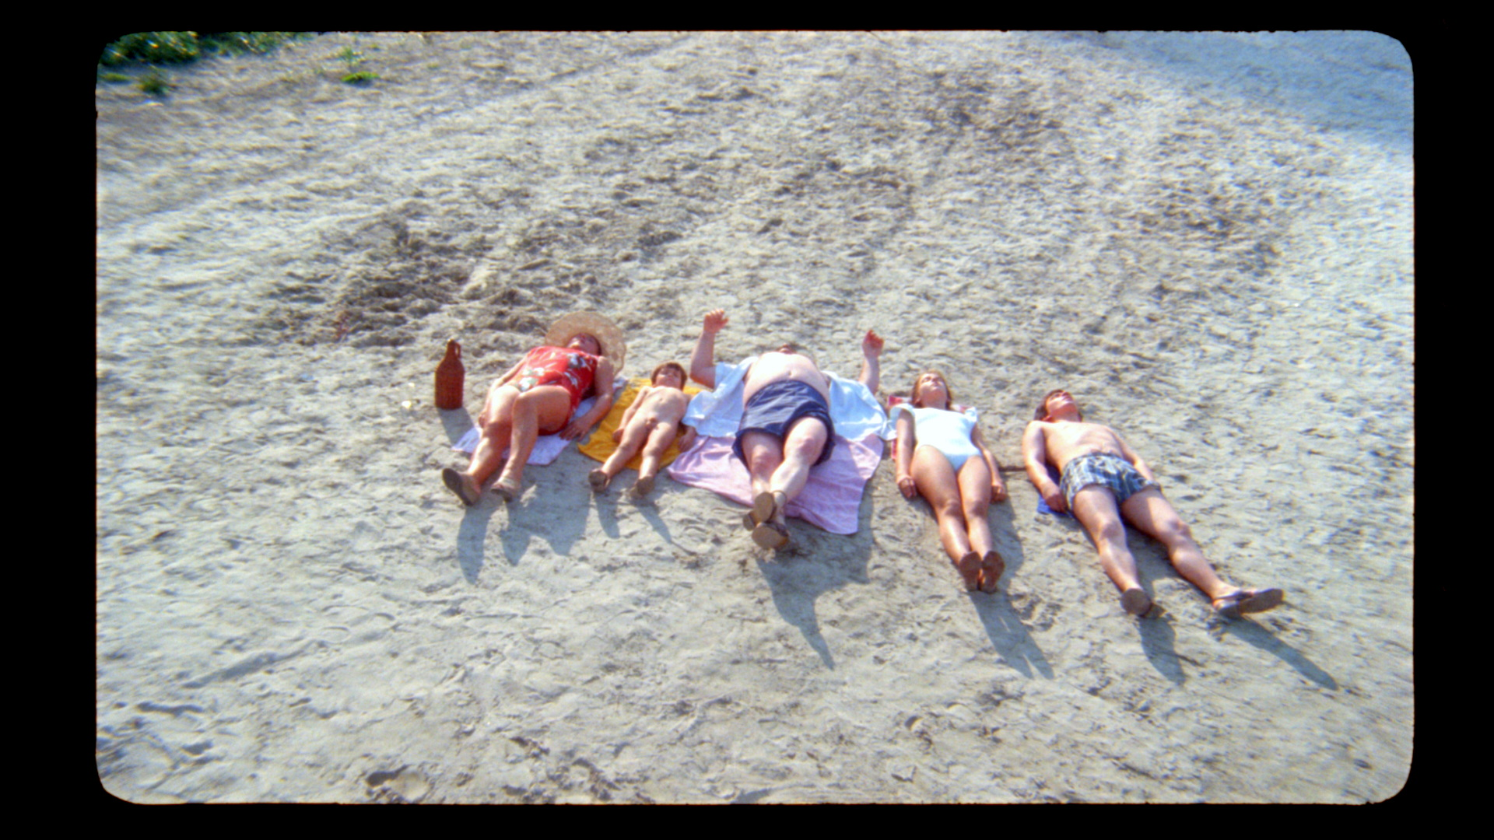

- The picture above shows one of the shots from the movie The Elusive Summer of ’68 . The central position in the frame is occupied by the protagonist's father, surrounded by other family members. Based on this picture, can we conclude something more about the family itself and their mutual relations. Describe in a few sentences how you experience this picture and how the director tries to show us the patriarchal environment of a province in the late 1960s.

- The film director, Goran Paskaljevic, belongs to a constellation of Serbian directors who have been given the symbolic name "Prague School". Do you know who the other directors who belong to this group are and why they got that name?

- In the film, The Elusive Summer of ’68, the world of the main character Petar is at the same time imaginary and real, inhabited by his fantasies towards mature women, but also his love for shy girls of his age.

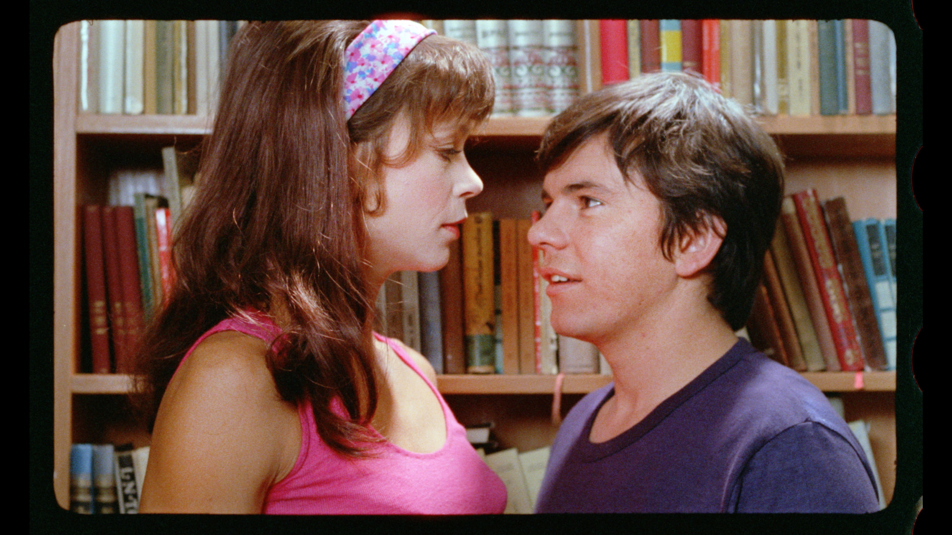

- Related to the pictures from the film, try to describe in a few sentences the thinking of the main character.
- In your opinion, to what extent do films influence the maturation of young people?

- FUN FACTS

- The Yugoslav Cinematheque, in cooperation with the company A1 and the producer of the film Centar Film, digitally restored this classic, and the premiere took place on August 23, 2018, at the closing of the first international film festival Danube Film Fest in Smederevo.

